Array

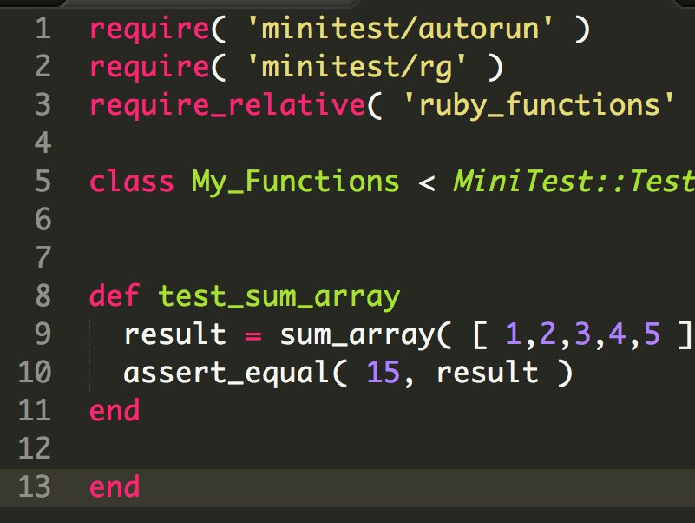

* 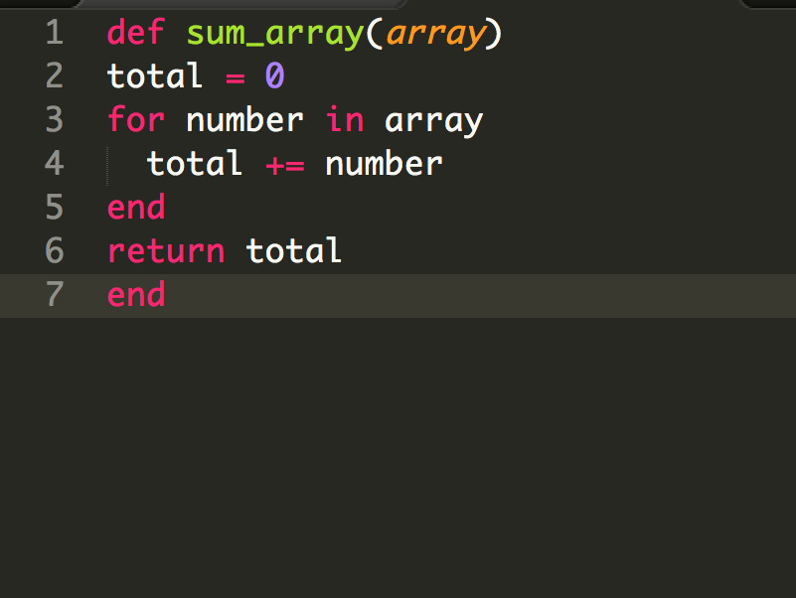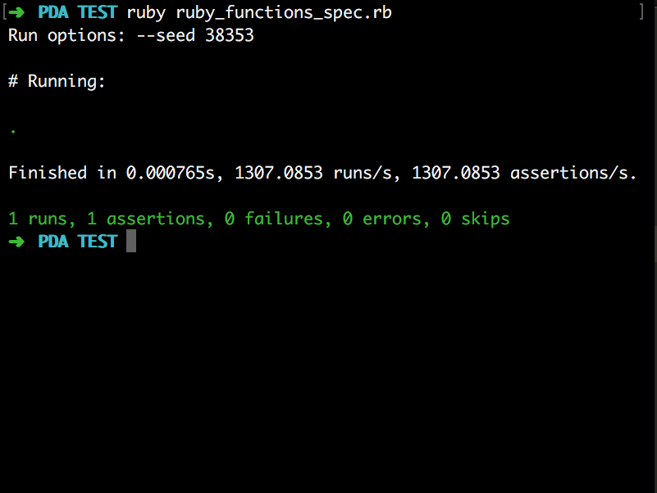TDD method used to set up array
* Expecting back 15 from method adding up all number in the array.
* Sum_array takes in an array and loops through it, adding each number up then returns the full total.
* Terminal view showing the TDD method has passed and returned the correct number.

Hashes

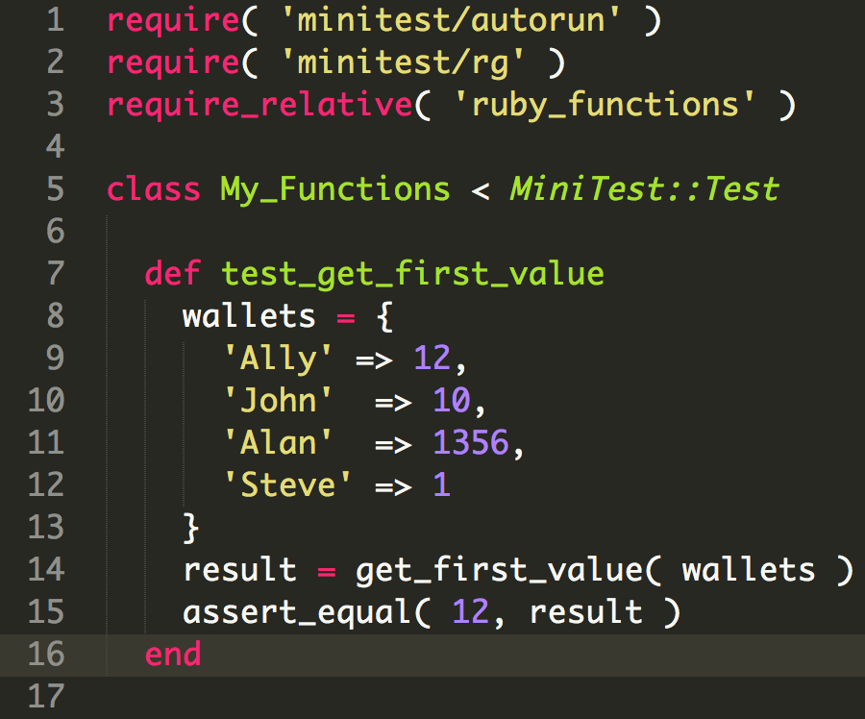

* TDD method used to set up hash
* Expecting back 12 from calling the method to return the value of ‘Ally’

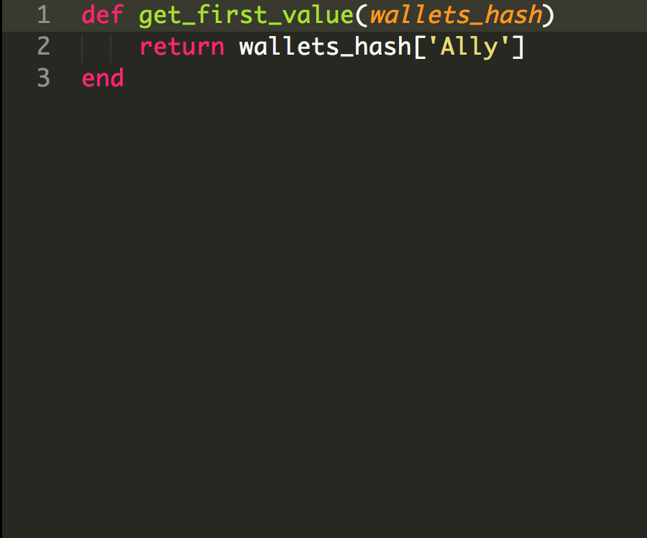

* Get first value returns the value associated with the given key ‘Ally’

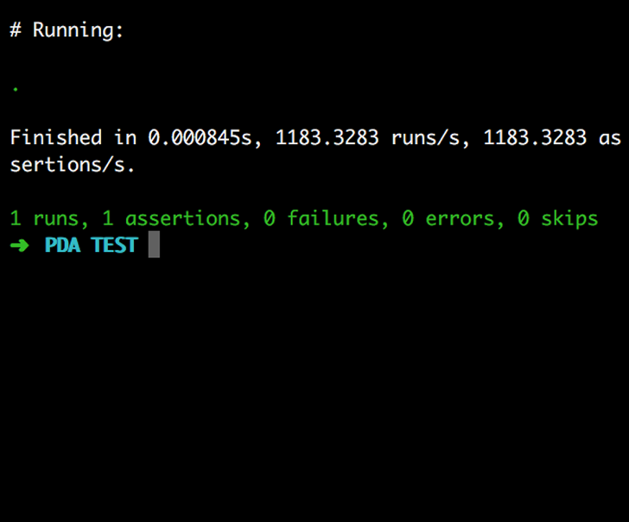

* Terminal view showing the TDD method has passed and returned the correct number.